**Chocolate and cycling assignment**

1. **Introduction**

**Background**

You have been hired by the U.S. bicycle team to help them train for the Tour de France. The head trainer recently read an article, which presents the results of a study about the effects of the consumption of chocolate (dark chocolate and white chocolate) on a number of important outcome variables during cycling. These outcome variables included: oxygen consumption (ml/kg/min), heart rate (bpm), blood lactate (BLa), blood pressure (mmHg), and an all-out bicycle sprint performance (meters).

The experimental setup consisted of a randomized crossover design where the various outcome variables of n = 9 male participants was measured in two trials after participants consumed either dark chocolate (40 grams of Dove) or white chocolate (40 grams of Milkybar), each for two weeks. A crossover design is a repeated measurements design such that each subject receives the two different treatments (dark chocolate versus white chocolate) during the different two-week time periods, i.e., the patients cross over from one treatment to another during the course of the experiment. The order of which treatment was received in the first time period was randomized. Prior to receiving the first treatment, each participant underwent baseline measurements on the outcome variables.

The trainer was specifically interested in the results for the all-out sprint performance which measured the distance traveled (in meters) for a two-minute time trial. He would like to know how the regular consumption of chocolate affects the total distance covered during an all-out sprint and if the type of chocolate consumed matters.

**Problem**

* Does the consumption of chocolate affect performance of U.S. bicycle team?
* If consumption of chocolate affects performance of U.S. bicycle team, is there a difference between white chocolate and dark chocolate?

1. **Data acquisition**

The data comes from a crossover study of nine participants who received white and dark chocolate.

**Sample size**: 9 participants.

* In this case, the sample is not enough to make an inference statistic, because this data does not work well with normality distribution formulas.

**Experiment:**

* This is a crossover experiment.
  + Advantages:
    - the influence of confounding covariates is reduced because each crossover patient serves as their own control.
    - It is statistically efficient, because requires fewer subjects.

1. **Exploratory data analysis**

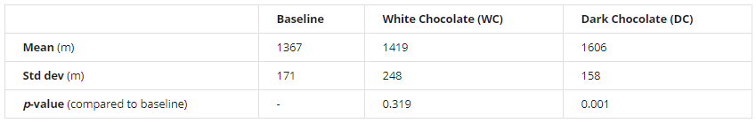

Dark chocolate

* 95% Confidence Interval for the population average change in total distance covered (dark chocolate over baseline) is 165 m to 314 m; (p-value 0.001).
  + **Confidence interval**: based on our sample of 9 participants, with 95% confidence, we estimate that participants who consume dark chocolate cover a distance between 165m and 134m higher than participants who do not consume dark chocolate.
  + **Hypothesis testing**: we have enough evidence to say that participants who consume dark chocolate cover more distance that participants who do not consume dark chocolate.

Dark versus white chocolate

* 95% Confidence Interval for the population average change in total distance covered (dark chocolate over white chocolate) is 82 m to 292 m; (p-value = 0.003).
  + **Confidence interval:** based on our sample of 9 participants, with 95% confidence, we estimate that participants who consume dark chocolate cover a distance between 82m and 292m higher than participants who consume white chocolate.
  + **Hypothesis testing:** we have enough evidence to say that participants who consume dark chocolate cover more distance than participants who consume white chocolate.

1. **References**

<https://s3-api.us-geo.objectstorage.softlayer.net/cf-courses-data/CognitiveClass/DP0701EN/sample_submission/Predicting_the_Improvement_of_NBA_players_Report.pdf>

<https://en.wikipedia.org/wiki/Crossover_study>